Server Instructions

- Connect to the Windows Machine using an RD connection tool.
- Provide the username, ip, and password.
- Credentials:
- Elastic IP 52.0.155.150
- User name Administrator
- Password uRVD*AsnuGY
- Navigate to C:\inetpub\wwwroot
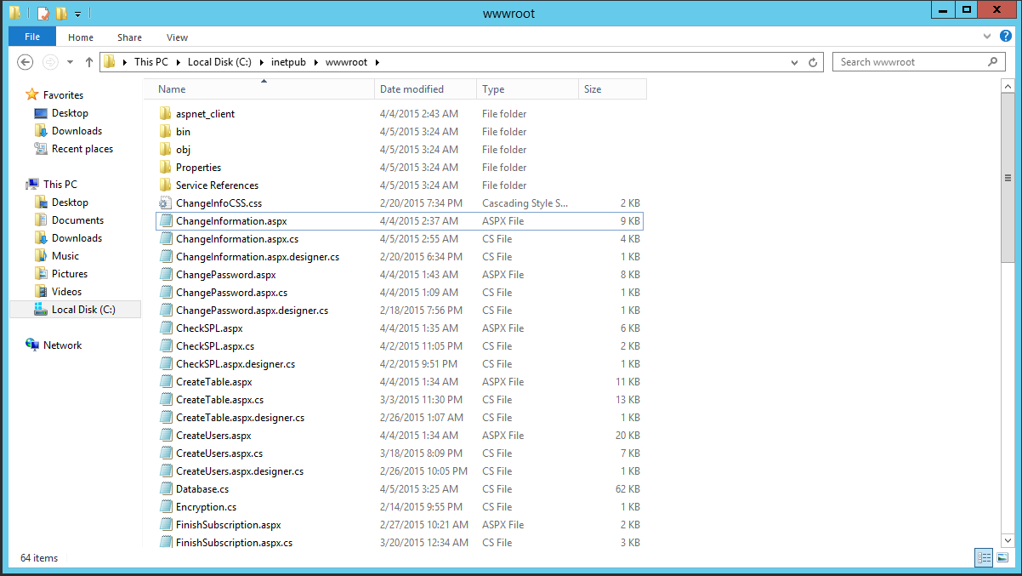
- There you will find the following:

Add or remove files as needed from the server.

DashBuilder Instructions
- Install Java, set JAVA_HOME, and set Java path.
- Install Maven, set MAVEN_HOME, and set Maven path.
- Install Git, optionally set Git path.
- Download Dashbuilder by executing this command:
  - git clone https://github.com/droolsjbpm/dashboard-builder.git
- After download is finished execute the following:
  - ./buildandrun.sh [db type]
- Access by typing in navigation bar:
  - http://localhost:8080/dashbuilder

Database Crendentials:

Password: marjaime1

